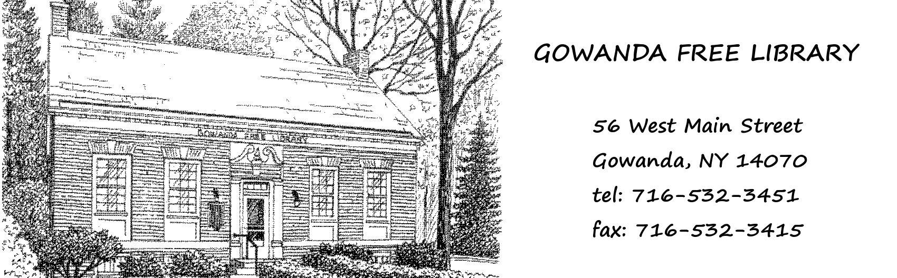Gowanda Free Library

56 West Main St.

Gowanda, NY 14070

Tel: 716-532-3451

Fax: 716-532-3415

Volunteer Application

# Volunteer Information Emergency Contact

Name: Name: Address: Address:

Phone: Phone: Email: Email:

Relationship:

# Are you a:

 Volunteer (age 18 or over)

 Junior Volunteer (under the age of 18)

# Availability for Volunteering:

 Regularly  Periodically  One-time or short-term project

|  |  |  |  |  |  |  |
| --- | --- | --- | --- | --- | --- | --- |
| Monday | Tuesday | Wednesday | Thursday | Friday | Saturday | Sunday |
| From: |  |  |  |  |  |  |
| To: |  |  |  |  |  |  |

# Reasons for Volunteering:

**Employment History:**

Employer: Employer: Address: Address: Phone: Phone: Supervisor: Supervisor:

Employer: Employer: Address: Address: Phone: Phone: Supervisor: Supervisor:

**Education, interests or special skills:** _______________________________________

**What type of volunteering are you interested in?**

**GOWANDA FREE LIBRARY**

**VOLUNTEER AGREEMENT**

(Age 18 or over)

I understand that I am a Volunteer for the Gowanda Free Library. As a volunteer, I understand that I will not be compensated (financially, or in any other manner) for my volunteer time. I further understand that I am not an employee of the Gowanda Free Library and I am not entitled to any benefits that are provided to employees of the Gowanda Free Library. I further understand that should I apply for future job openings, the Gowanda Free Library is under no obligation to hire me.

I understand that my volunteer service is “at will” and may be terminated at any time and for any reason, by myself or library administration, with or without notice. As a Gowanda Free Library volunteer, I will try and provide a minimum of 2 weeks’ notice to the B&ECPL to end my volunteer service.

As a volunteer, I agree to follow all Gowanda Free Library Patron and Employee Policies and Rules of Conduct. I understand my obligation of confidentiality and agree to maintain the confidentiality of patrons and staff. I understand I am not permitted to remove or make copies of any records, reports or documents from the Gowanda Free Library.

As I volunteer, I understand that I am under no obligation to perform duties that I feel may be outside of the scope of my physical abilities or which I consider hazardous to my health or well being. The Gowanda Free Library is not responsible for any injuries I may sustain while volunteering.

As a Gowanda Free Library volunteer, I am considered a library advocate and supporter and I agree to perform my volunteer duties in a professional and credible manner and act in the best interests of the Gowanda Free Library.

# Signature: Date:

**GOWANDA FREE LIBRARY**

**JUNIOR VOLUNTEER AGREEMENT**

(Under the age of 18)

I understand that my minor child is a Junior Volunteer for the Gowanda Free Library. As a volunteer, I understand that my minor child will not be compensated (financially, or in any other manner) for his/her volunteer time. I further understand that he/she is not an employee of the Gowanda Free Library and is not entitled to any benefits that are provided to employees of the Gowanda Free Library. I further understand that should he/she apply for future job openings, the Gowanda Free Library is under no obligation to hire him/her.

I understand that my minor child’s volunteer service is “at will” and may be terminated at any time and for any reason by himself/herself or the library administration, with or without notice. As a Gowanda Free Library volunteer, he/she will try and provide a minimum of 2 weeks’ notice to the Gowanda Free Library to end his/her volunteer service.

As a volunteer, my minor child agrees to follow all Gowanda Free Library Policies and Rules of Conduct. I understand his/her obligation of confidentiality and agree to maintain the confidentiality of patrons and staff. I understand he/she is not permitted to remove or make copies of any records, reports or documents from the Gowanda Free Library.

As a volunteer, I understand that my minor child is under no obligation to perform duties that he/she feels may be outside of the scope of his/her physical abilities or which he/she considers hazardous to his/her health or well being. I understand that the Gowanda Free Library is not responsible for any injuries he/she may sustain while volunteering.

As a Gowanda Free Library volunteer, my minor child is considered a library advocate and supporter and agrees to perform his/her volunteer duties in a professional and credible manner and act in the best interests of the Gowanda Free Library.

Minor(s) Name(s), Date of Birth (DOB), and Age

Name: DOB: Age: Name: DOB: Age: Name: DOB: Age: Name: DOB: Age:

# Legal Guardian’s Signature: Print Name: Date: